Create Multiple Service
- Create Service
>> ng g s services/helloService
>> ng g s services/customerService
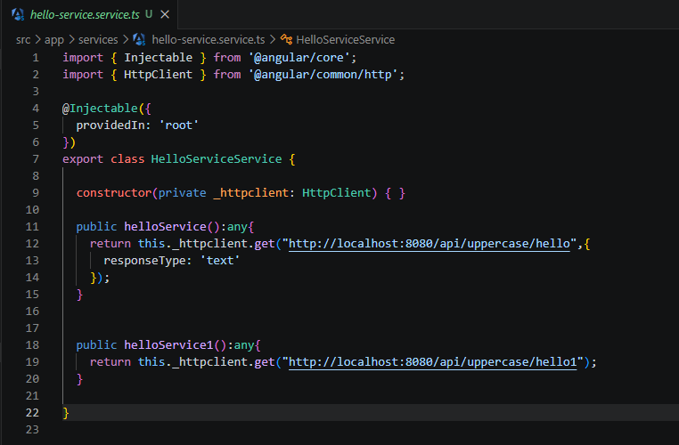

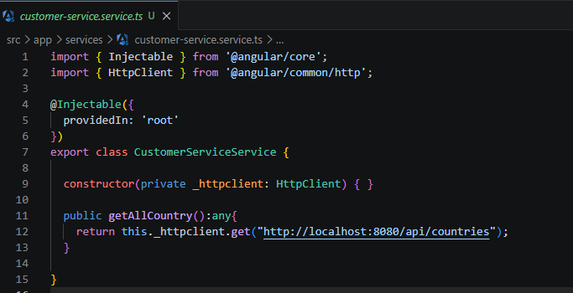

import { Injectable } from '@angular/core';
import { HttpClient } from '@angular/common/http';

@Injectable({
providedIn: 'root'
})
export class HelloServiceService {

constructor(private _httpclient: HttpClient) { }

public helloService():any{
return this._httpclient.get("http://localhost:8080/api/uppercase/hello",{
responseType: 'text'
});
}

public helloService1():any{
return this._httpclient.get("http://localhost:8080/api/uppercase/hello1");
}

}

import { Component, OnInit } from '@angular/core';
import { CustomerServiceService } from 'src/app/services/customer-service.service';
import { HelloServiceService } from 'src/app/services/hello-service.service';

@Component({
selector: 'app-multiple-services',
templateUrl: './multiple-services.component.html',
styleUrls: ['./multiple-services.component.css']
})
export class MultipleServicesComponent implements OnInit {

public helloResponse:any;
public helloResponse1:any;
public countryResponse:any;
public testshow:any = "Hello You";

constructor(private _helloService: HelloServiceService, private _customerService: CustomerServiceService) { }

ngOnInit(): void {
this._helloService.helloService().subscribe((res:any)=>this.helloResponse=res);
this._helloService.helloService1().subscribe((res:any)=>this.helloResponse1=res);
this._customerService.getAllCountry().subscribe((res:any)=>this.countryResponse=res);
}

}

2. Create component
>> ng g c components/multipleServices

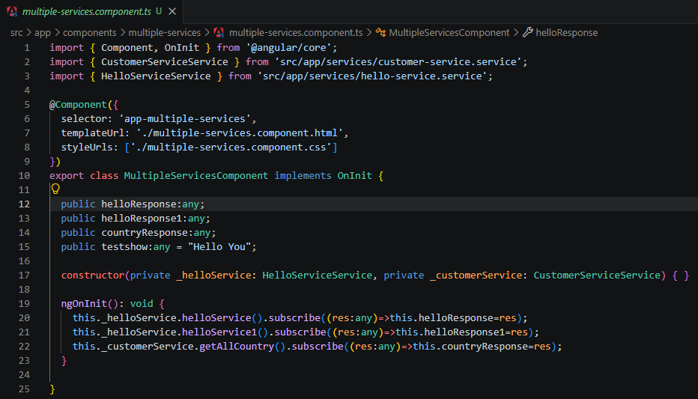

import { Component, OnInit } from '@angular/core';
import { CustomerServiceService } from 'src/app/services/customer-service.service';
import { HelloServiceService } from 'src/app/services/hello-service.service';

@Component({
selector: 'app-multiple-services',
templateUrl: './multiple-services.component.html',
styleUrls: ['./multiple-services.component.css']
})
export class MultipleServicesComponent implements OnInit {

public helloResponse:any;
public helloResponse1:any;
public countryResponse:any;
public testshow:any = "Hello You";

constructor(private _helloService: HelloServiceService, private _customerService: CustomerServiceService) { }

ngOnInit(): void {
this._helloService.helloService().subscribe((res:any)=>this.helloResponse=res);
this._helloService.helloService1().subscribe((res:any)=>this.helloResponse1=res);
this._customerService.getAllCountry().subscribe((res:any)=>this.countryResponse=res);
}
}
- Html
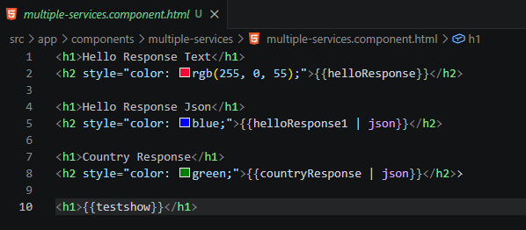

<h1>Hello Response Text</h1>
<h2 style="color: rgb(255, 0, 55);">{{helloResponse}}</h2>

<h1>Hello Response Json</h1>
<h2 style="color: blue;">{{helloResponse1 | json}}</h2>

<h1>Country Response</h1>
<h2 style="color: green;">{{countryResponse | json}}</h2>>

<h1>{{testshow}}</h1>

----------------------- ------------------------------------------------------------------------------------------

- App.module.ts

- First : add provider : កន្លែង ដែលយើងដាក់ service (providers: [HelloServiceService, CustomerServiceService ] )
- import { HttpClientModule } from '@angular/common/http' : យើងត្រូវធ្វើការ import HttpClientModule ដើម្បីប្រើប្រាស់ httpClient
- bootstrap: [MultipleServicesComponent] : កន្លែង starter app

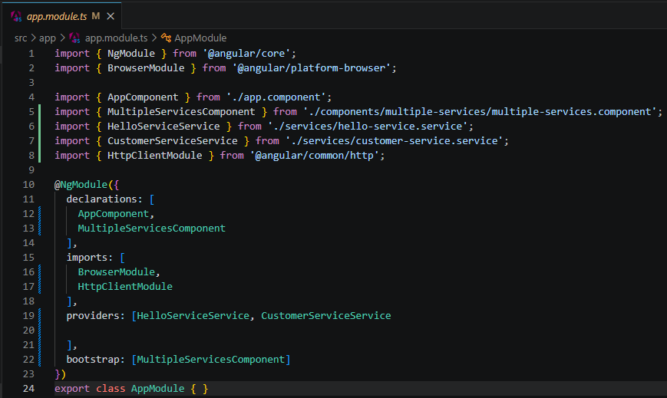

- index.html

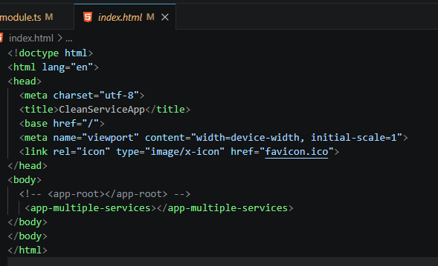

យើងត្រូវដាក់ <app-multiple-services></app-multiple-services>

Improving

ដោយសារតែនៅក្នុង life cycle : ngOnInit(): void {} វាធ្វើការ ហៅ service ម្តង់មួយមកប្រើចឹង ធ្វើអោយ service នឹងមាន delay យើងអាចធ្វើការ Improve វាបានដោយ ប្រើ forkJoin
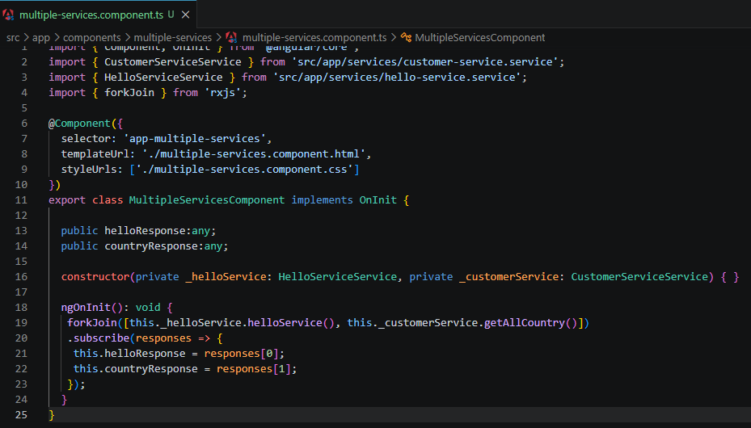

ngOnInit(): void {
forkJoin([this._helloService.helloService(), this._customerService.getAllCountry()])
.subscribe(responses => {
this.helloResponse = responses[0];
this.countryResponse = responses[1];
});
}

Error Angular Version in VS code:
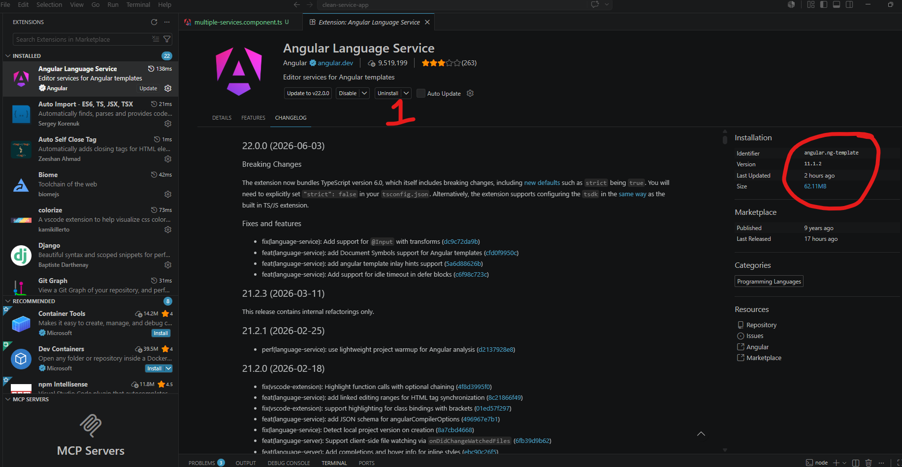

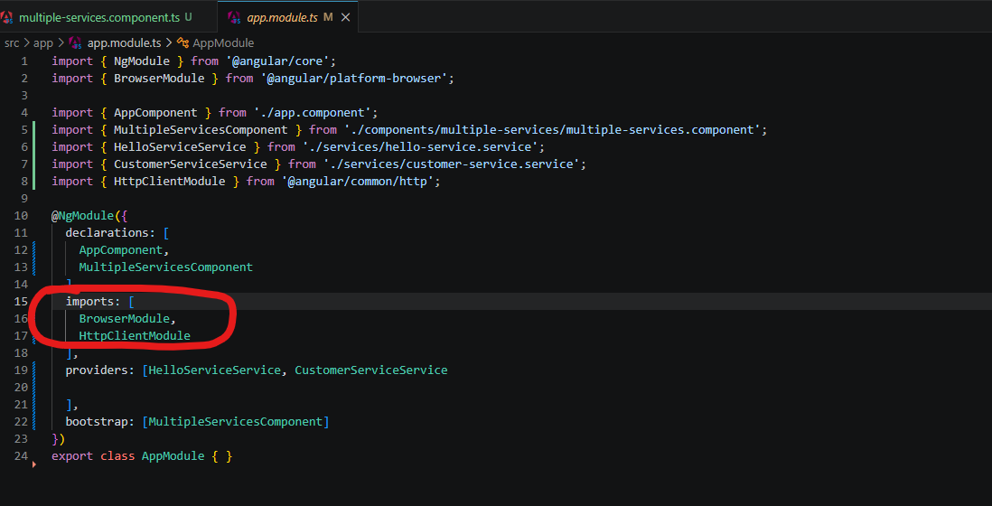

កន្លែងដែលវា Error

